# COPE-COMPARE: Transplantation Data

## Kidney Allocation:

Kidney: Left Right

Name Transplant Technician:

Phone Call Received from Colleague Technician involved in Donor Procedure:

___/___/______ Time: ___:___

Name Colleague involved in Donor Procedure:

Transplant Hospital:

* 41 Universitaire Ziekenhuizen Leuven, Belgium
* 42 Universitair Ziekenhuis Antwerpen, Belgium
* 43 Universitair Ziekenhuis Brussel, Belgium
* 44 Université Catholique de Louvain, Belgium
* 45 Université Libre de Bruxelles, Belgium
* 46 Centre Hospitalier de Liège, Belgium
* 47 Universitair Ziekenhuis Gent, Belgium
* 51 Universitair Medisch Centrum Groningen, Netherlands
* 52 Maastricht Universitair Medisch Centrum, Netherlands
* 53 Leids Universitair Medisch Centrum, Netherlands
* 54 Universitair Medisch Centrum Utrecht, Netherlands
* 55 Amsterdam Medisch Centrum, Netherlands
* 56 Universitair Medisch Centrum Nijmegen, Netherlands
* 57 Erasmus Medisch Centrum, Netherlands
* 58 VU Medisch Centrum, Netherlands

Name Transplant Hospital’s operating theatre contact person:

Telephone number Transplant Hospital’s Operating Theatre Contact Person:

Scheduled Start Transplant: ___/___/______ Time: ___:___

Arrival at Hub: ___/___/______ Time: ___:___

Departure from Hub: ___/___/______ Time: ___:___

Arrival at Transplant Hospital: ___/___/______ Time: ___:___

Remarks:

……………………………………………………………………………………………………………………………………………………………………………………………………………………………………………………………………………………………….………………………

Kidney Re-Allocation to another Transplant Centre: Yes No

If Yes,

Reason for Re-Allocation:

* Positive Crossmatch
* Other: ………………………………………………………………………………………………………………………
* Unknown

Name New Transplant Hospital’s Operating Theatre Contact Person:

Telephone Number:

New Transplant Hospital:

* 41 Universitaire Ziekenhuizen Leuven, Belgium
* 42 Universitair Ziekenhuis Antwerpen, Belgium
* 43 Universitair Ziekenhuis Brussel, Belgium
* 44 Université Catholique de Louvain, Belgium
* 45 Université Libre de Bruxelles, Belgium
* 46 Centre Hospitalier de Liège, Belgium
* 47 Universitair Ziekenhuis Gent, Belgium
* 51 Universitair Medisch Centrum Groningen, Netherlands
* 52 Maastricht Universitair Medisch Centrum, Netherlands
* 53 Leids Universitair Medisch Centrum, Netherlands
* 54 Universitair Medisch Centrum Utrecht, Netherlands
* 55 Amsterdam Medisch Centrum, Netherlands
* 56 Universitair Medisch Centrum Nijmegen, Netherlands
* 57 Erasmus Medisch Centrum, Netherlands
* 58 VU Medisch Centrum, Netherlands

New Scheduled Transplant Start: ___/___/______ Time: ___:___

Arrival at New Transplant hospital: ___/___/______ Time: ___:___

Additional Comments:

………………………………………………………………………………………………………………………………………………………………………………………………………………………………………………………………………………………………

Technician’s Departure Transplant Hospital: ___/___/______ Time: ___:___

Arrival Technician at Hub: ___/___/______ Time: ___:___

End Time of Entire Procedure for Technician: ___/___/______ Time: ___:___

General Comments:

………………………………………………………………………………………………………………………………………………………………………………………………………………………………………………………………………………………………………………………………………………………………………………………………………………………………………………..……………………………………

## Recipient Consent:

Name Transplant Centre:

Is the recipient > 18 years: Yes No

He/she will undergo a single Kidney Transplant: Yes No

Signed Informed Consent: Yes No

**If one question is answered with No, Do NOT collect data or samples!**

Trial ID Recipient:

## Recipient Identification:

ET/NHSBT Number:

Date Of Birth: ___/___/______

Gender: Female Male

Weight (kg):

Height (cm):

Ethnicity: Caucasian Black Other Unknown

Renal Disease:

* Glomerular Diseases
* Polycystic Kidneys
* Uncertain Etiology
* Tubular and Interstitial Diseases
* Retransplant Graft Failure
* Diabetic Nephropathyes
* Hypertensive Nephroangiosclerosis
* Congenital, rare Familial Metabolic Disorders
* Renovascular and Other Renal Vascular Diseases
* Neoplasms
* Other:………………………………………………………………………………………………………………………….

Pre-Transplant Diuresis (ml/24hr):

Recipient Blood Group: O A B AB

General Comments:

………………………………………………………………………………………………………………………………………………………………………………………………………………………………………………………………………………………………………………………………………………………………………………………………………………………………………………..……………………………………

## Recipient Peri-Operative Data:

Transplantation Date: ___/___/______ Time: ___:___

pO2 perfusate: (Measure before stopping Kidney Assist)

Stop Machine Perfusion: ___/___/______ Time: ___:___

* Kidney was Cold Stored

Was the Tape over the Regulator Broken: Yes No

Kidney Removed from Machine: ___/___/______ Time: ___:___

Oxygen Bottle Full and Turned Open: Yes No Unknown

Kidney Discarded / Untransplantable: Yes No

If Yes, please provide details:

………………………………………………………………………………………………………………………………………………………………………………………………………………………………………………………………………………………………………………………………………………………………………………………………………………………………………………

Start Anesthesia: ___/___/______ Time: ___:___

Incision:

* Midline Laparotomy
* Hockey Stick (Extra Peritoneal)
* Unknown

Transplant Side: Left Right

Arterial Problems:

* No
* Ligated Polar Artery
* Reconstructed Polar or Hilar Artery
* Repaired Intima Dissection
* Other: …………………………………………………………………………………………………………………………

Venous Problems:

* No
* Laceration
* Elongation Plasty
* Other: …………………………………………………………………………………………………………………………

Start Anastomosis: ___/___/______ Time: ___:___

Reperfusion: ___/___/______ Time: ___:___

Mannitol Used: Yes No Unknown

Other Diuretics Used: Yes No Unknown

If Yes, please specify:

………………………………………………………………………………………………………………………………………………………………………………………………………………………………………………………………………………………………………………………………………………………………………………………………………………………………………………

Systolic Blood Pressure at Reperfusion:

CVP at Reperfusion:

Intra-Operative Diuresis: Yes No Unknown

Remarks:

………………………………………………………………………………………………………………………………………………………………………………………………………………………………………………………………………………………………………………………………………………………………………………………………………………………………………………..……………………………………

## WP7 Sampling:

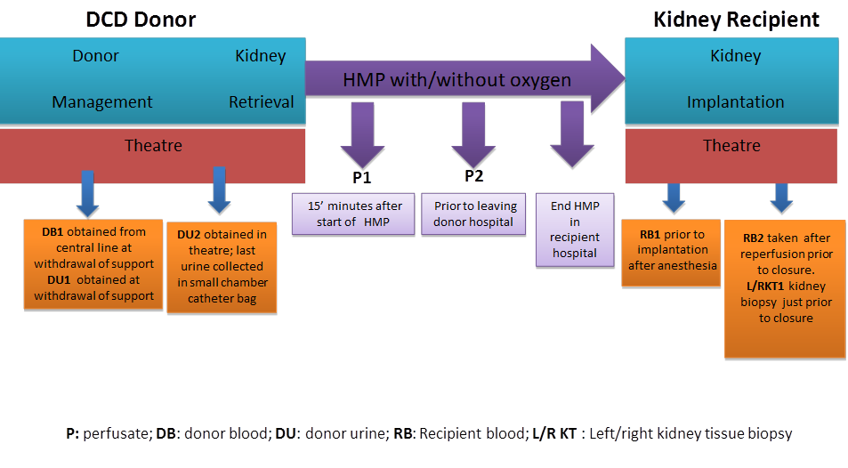

**P3**

Barcode COPE-box:

Kidney: Left Right

|  |  |  |  |
| --- | --- | --- | --- |
|  | **Barcode** | **Time taken** | **Time centrifugation** |
| **P3** |  | ___/___/______ Time: ___:___ |  |
| **RB 1.1 EDTA** |  | ___/___/______ Time: ___:___ | ___/___/______ Time: ___:___ |
| **RB 1.2 SST** |  | ___/___/______ Time: ___:___ | ___/___/______ Time: ___:___ |
| **RB 2.1 EDTA** |  | ___/___/______ Time: ___:___ | ___/___/______ Time: ___:___ |
| **RB 2.2 SST** |  | ___/___/______ Time: ___:___ | ___/___/______ Time: ___:___ |
| **K T1 formalin** |  | ___/___/______ Time: ___:___ |  |
| **K T1 RNAlater** |  | ___/___/______ Time: ___:___ |  |

General Comments:

…………………………………………………………………………………………………………………………………………………………………………………………………………………………………………………………………………………………………………………………

…………………………………………………………………………………………………………………………………………………………………………………………………………………………………………………………………………………………………………………………

## Cleaning Log:

|  |  |  |
| --- | --- | --- |
| **Materials** | **Comments** | **Signature** |
| Temperature & flow probe cleaned |  |  |
| Ice & water removed |  |  |
| Oxygen bottle removed/ Oxygen flow stopped |  |  |
| Box Kidney Assist cleaned |  |  |
| Batteries charged |  |  |